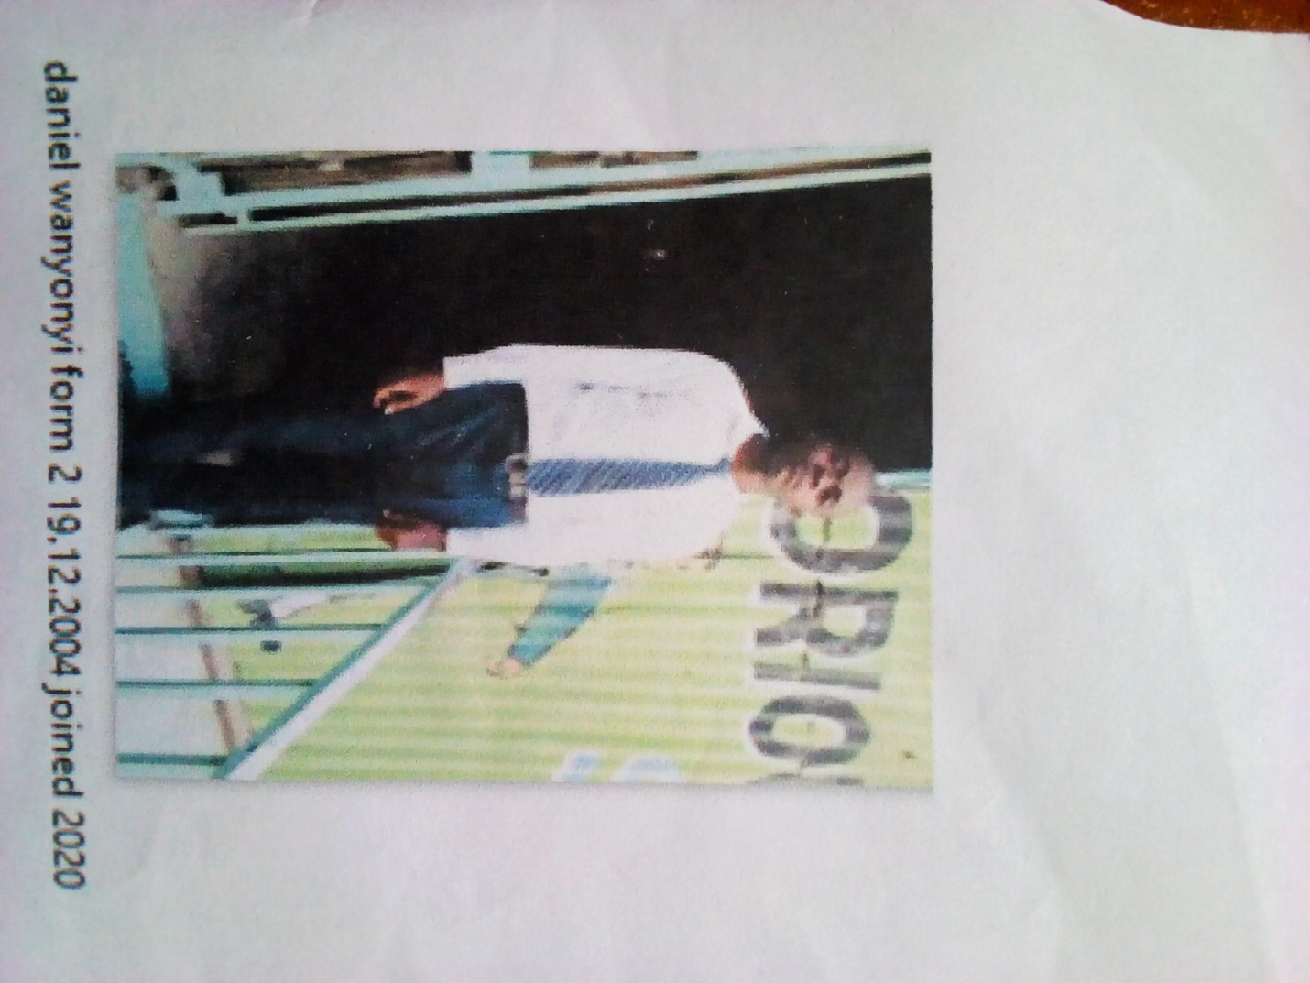

DANIEL WANYONYI FORM 2 BORN 2004 JOINED 2020
Daniel 17 years was enrolled in our school when he was 16 years old. Daniel is a needy boy, picked from the streets of Reuben; Daniel looked lost and had had no hope. People who brought him to school said he is a bright boy which has subsequently been verified. He sought help in school and he became accepted in school after the Director was contacted.
Thanks to the Director Mr. Boniface Mangeti who allowed Daniel in school. I am now learning in glorious at least I have a place I call home praying that one day God will help our school have good classes, toilets and enough learning materials. Thank you Michell and Brad for your support have really helped many in Mukuru

